**CHANDIGARH UNIVERSITY**

**UNIVERSITY INSTITUTE OF ENGINEERING**

**DEPARTMENT OF COMPUTER SCIENCE AND ENGINEERING**



|  |  |
| --- | --- |
| **Submitted by:**  Yash Gupta  20BCS5009 | **Submitted To:**  Er. Bhupinder Singh  (12856) |
| **Subject Name:** | Multimedia Technologies Lab |
| **Subject Code:** | 20CSP-339 |
| **Branch:** | CSE |
| **Semester:** | 5th |

LAB INDEX

|  |  |  |  |  |  |  |  |
| --- | --- | --- | --- | --- | --- | --- | --- |
| **Sr.No** | **Program** | **Date** | **Evaluation** | | | | **Sign** |
| **LW(12)** | **VV(8)** | **FW(10)** | **Total (30)** |
|  |  |  |  |  |  |  |  |
|  |  |  |  |  |  |  |  |
|  |  |  |  |  |  |  |  |
|  |  |  |  |  |  |  |  |
|  |  |  |  |  |  |  |  |
|  |  |  |  |  |  |  |  |
|  |  |  |  |  |  |  |  |

**Experiment 9**

**Student Name: Yash Gupta UID: 20BCS5009**

**Branch: BE-CSE Section/Group: 20BCS-MM-806 A**

**Semester: 5 Date of Performance: 29-09-2022**

**Subject Name: MMT LAB Subject Code:**

**Aim :-**

Draw a walking track on one layer. On another layer draw a stickman, with animation show the man walking over the track from left to right using Macromedia flash.

**Hardware Requirements: -**

Minimum 384MB RAM, 100 GB hard Disk, processor with 2.1 MHz.

**Software Requirements: -**

Adobe Photoshop, Photopea.

**Steps :-**

**Step 1:**

**Go to Macromedia Flash 8, click on the flash document→click ok.**

**Step 2:**

**Rename layer 1 as track, draw the track and convert it into a symbol (F8).**

**Step 3:**

**Insert another layer rename it as a stickman.**

**Step 4:**

**Draw a stickman and convert it into a symbol and insert a keyframe on the stickman layer and insert a frame(F5) on the track layer.**

**Step 5:**

**Delete the stickman and repeat step 4 by changing the position of a stickman and insert keyframe with the interval of 5.**

**Step 6:**

**Repeat the same steps 5 to 6 times and press Ctrl + Enter to test the movie.**

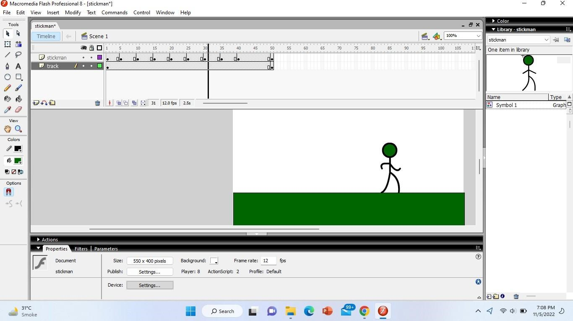

# Output :-

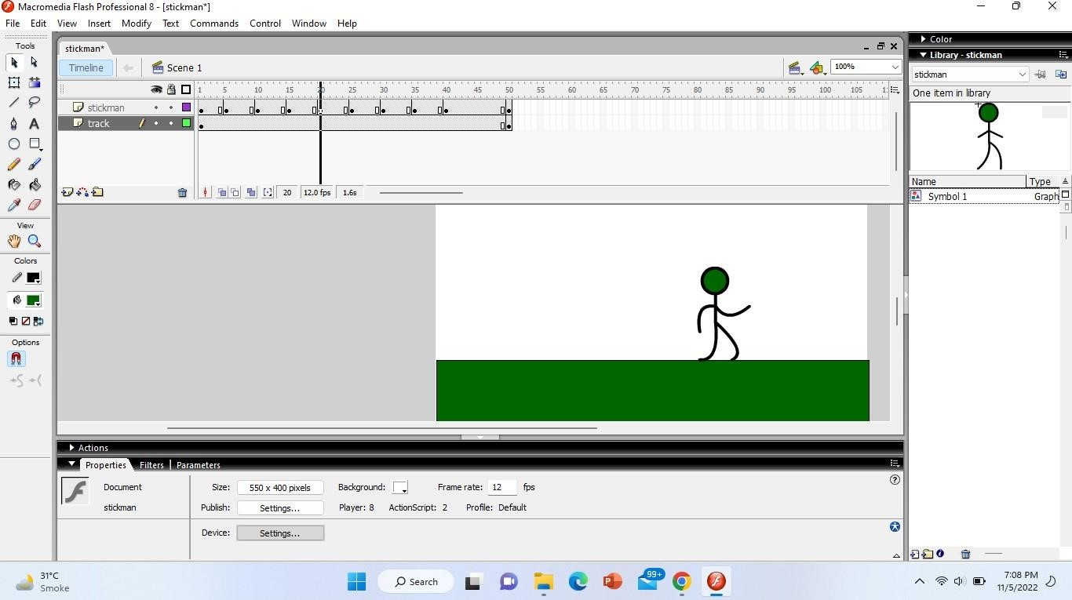

**Evaluation Grid (To be created as per the SOP and Assessment guidelines by the faculty):**

|  |  |  |  |
| --- | --- | --- | --- |
| Sr. No. | Parameters | Marks Obtained | Maximum Marks |
| 1. |  |  |  |
| 2. |  |  |  |
| 3. |  |  |  |